Prompt 1: All phases implementation
Analyze my Architecture.md file .Proceed with Phase by Phase Implementation.After completing one phase ASK my approval to prcoeed with next phase . Also create API collection /Appending API's for each phase (if applicable) to test the same .Also specify whether the Testing of Backend API is applicable for the phases with Implemntation in the current phase as Summary

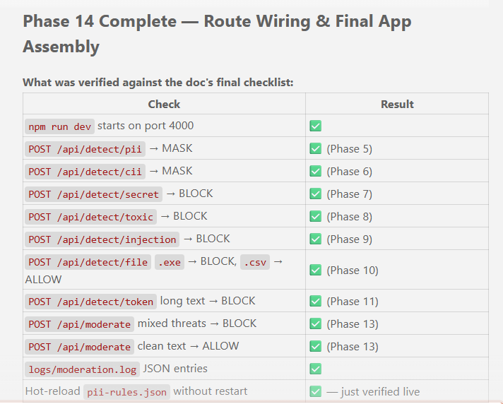
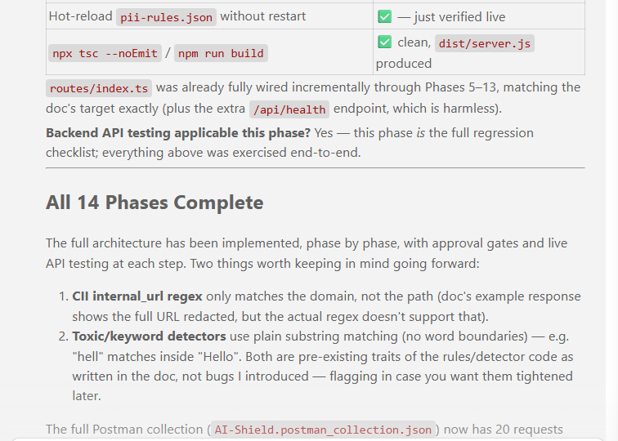
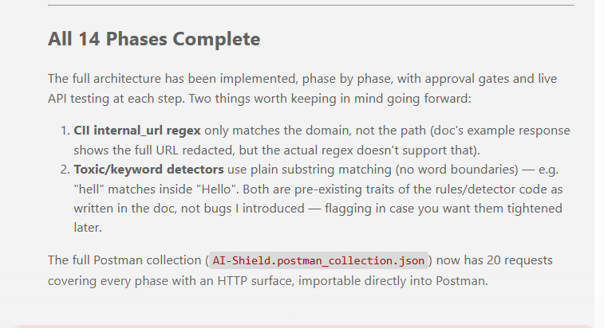

Prompt 2: Prepare the Unit testcases:
Generate Postman Collection (.json) containing unit testcases test cases for every API.
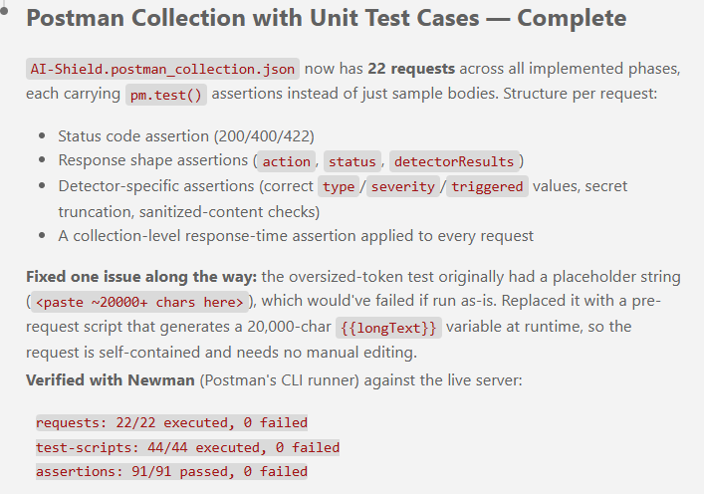
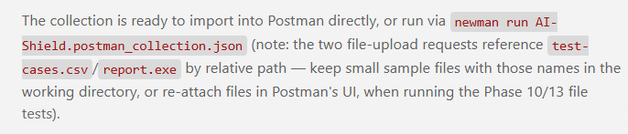
Prompt 3: Ask to run entire scripts and provide reports
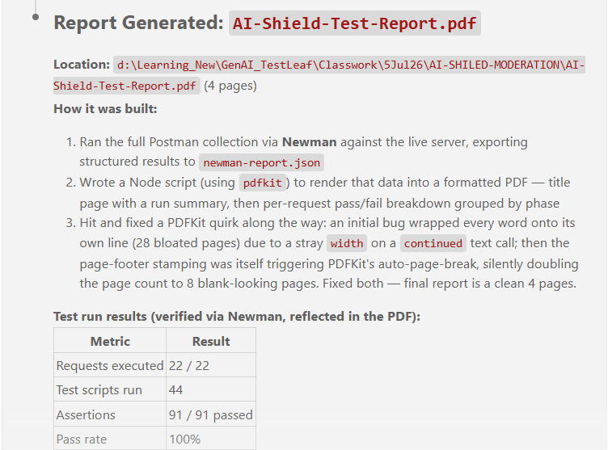
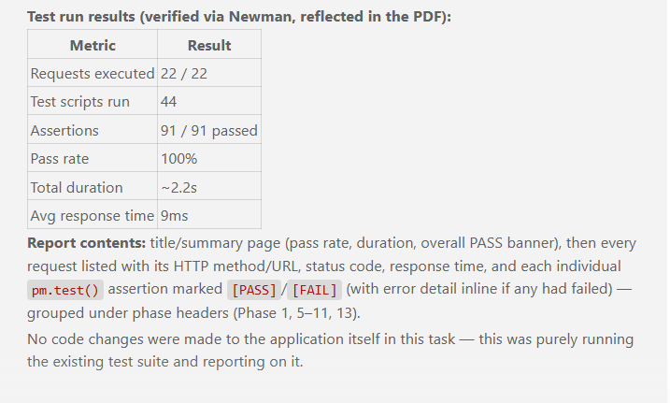
Prompt 4: I want to manually make this app up and running with npm run dev.Kill all the existing prcoess and once after Killing the process Summarize me ,to make this app up and running manually from the Terminal with powershell
Run it manually from PowerShell
- Open a PowerShell terminal and go to the project folder:
- cd "D:\Learning_New\GenAI_TestLeaf\Classwork\5Jul26\AI-SHILED-MODERATION"
(Only if node_modules is missing/stale) Install dependencies: npm install
- Start the dev server: npm run dev
This runs ts-node-dev --respawn --transpile-only src/server.ts — it auto-restarts on file changes.
- Once it's up you'll see: 🛡️ AI-Shield running on http://localhost:4000
- Open http://localhost:4000 in your browser to confirm it's working.
- To stop it later, press Ctrl+C in that terminal (or kill by port if needed):
Get-NetTCPConnection -LocalPort 4000 | Select-Object -ExpandProperty OwningProcess -Unique | Stop-Process -Force
That's it — just npm run dev from the project root going forward, as long as port 4000 is free.
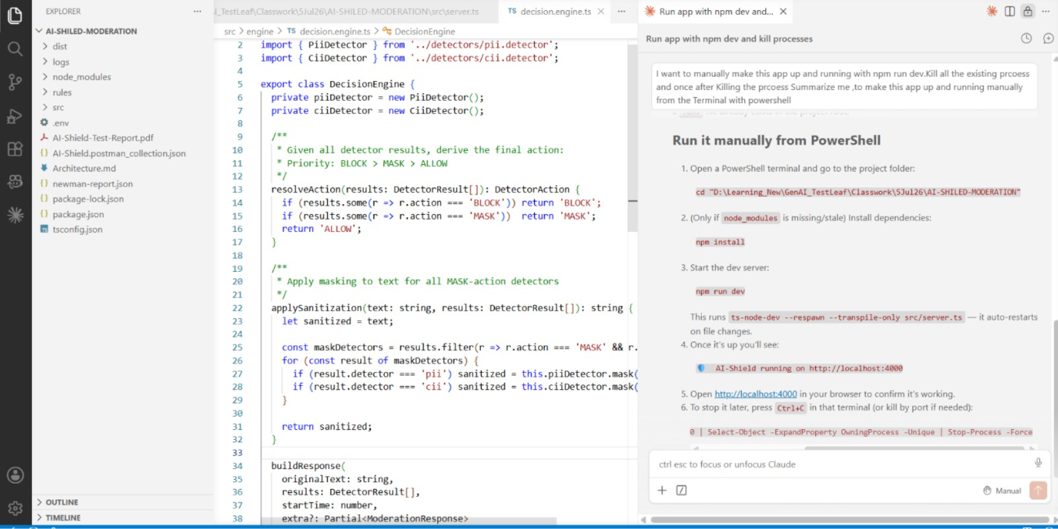
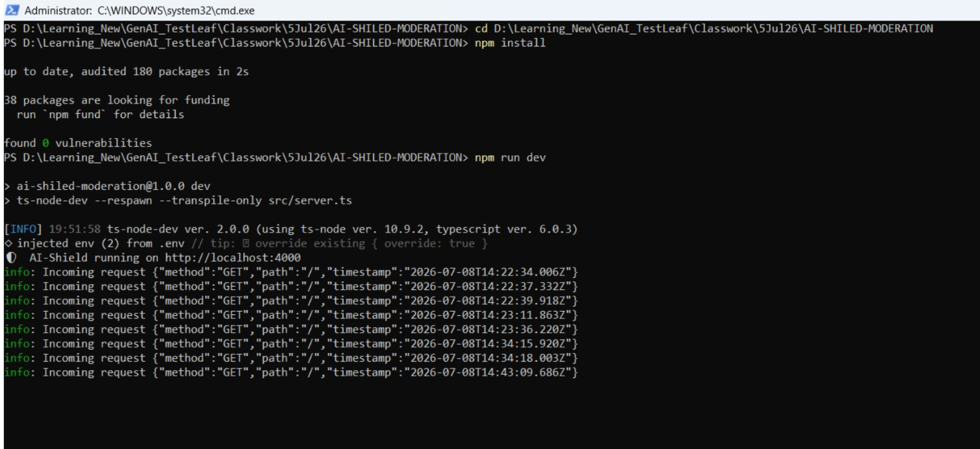
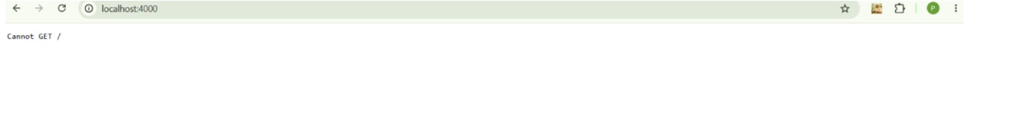
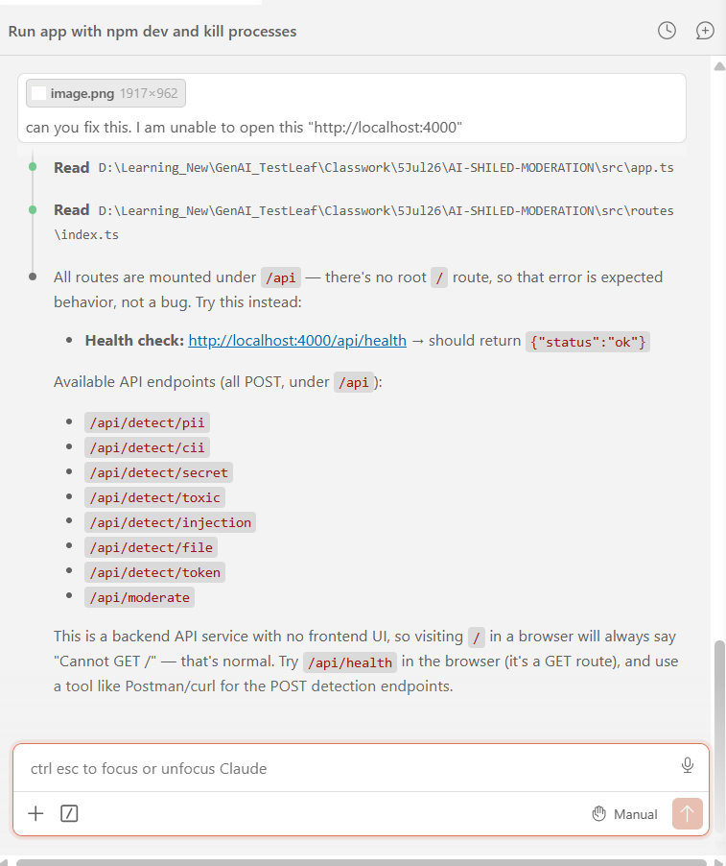
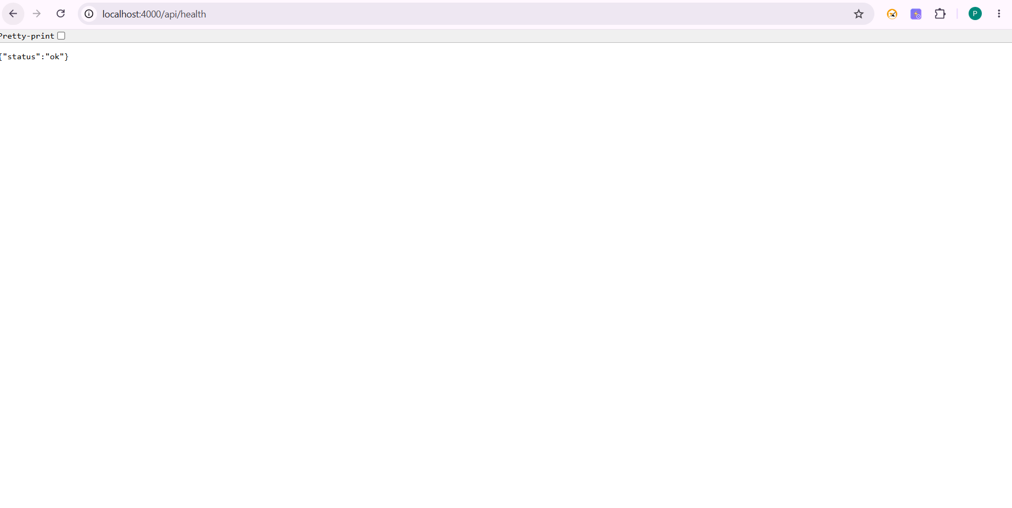
Prompt 5: Can you write unit test cases for this project